ACIDS & BASES

PAST EXAM QUESTIONS

Section 1: Brønsted-Lowry theory, conjugate acids & bases 2

Section 2: Polyprotic acids, acid strength, hydrolysis of salts 8

Section 3: Self-ionisation of water, K_{w}, pH calculations 17

Section 4: Equilibrium systems, acid dissociation constants, buffers 27

Section 5: Ocean acidification, models of acids and bases 38
WACE 2016 Sample Exam Q5: Originally from WACE 3AB 2012
Consider the following equation:
HS⁻(aq) + CO₃²⁻(aq) ⇌ S²⁻(aq) + HCO₃⁻(aq)
Which one of the following is not true of this equation?
- HCO₃⁻ is acting as a Brønsted-Lowry acid
- CO₃²⁻ is acting as a conjugate base
- HS⁻ is acting as a conjugate base
- S²⁻ is acting as a Brønsted-Lowry base

WACE 2016 Sample Exam Q4:
Which one of the following reactions does not represent the Brønsted-Lowry model?
- HSO₄⁻(aq) + H₂O(ℓ) → SO₄²⁻(aq) + H₃O⁺(aq)
- CH₃COOH(aq) + NaOH(aq) → NaCH₃COO(aq) + H₂O(ℓ)
- HCO₃⁻(aq) + H₂O(ℓ) → H₂CO₃(aq) + OH⁻(aq)
- CaCO₃(s) + 2 HCℓ(aq) → CaCℓ₂(aq) + CO₂(g) + 2 H₂O(ℓ)

WACE 2AB 2014 Q17:
In which one of the following equations is the underlined species acting as a Brønsted-Lowry base?
- NH₃ + CH₃COOH ⇌ NH₄⁺ + CH₃COO⁻
- HCO₃– + H₂O ⇌ H₂CO₃ + OH–
- HPO₄²⁻ + CH₃COOH ⇌ H₂PO₄⁻ + CH₃COO⁻
- NH₄⁺ + OH⁻ ⇌ NH₃ + H₂O

WACE 2AB 2012 Q21:
Which equation below best represents the H₂PO₄⁻ ion acting as a Brønsted-Lowry acid?
- H₂PO₄⁻(aq) → 2 H⁺(aq) + PO₄³⁻(aq)
- H₂PO₄⁻(aq) + OH⁻(aq) → H₃PO₄(aq) + H₂O(ℓ)
- H₂PO₄⁻(aq) + H₂O(ℓ) → H₃PO₄(aq) + OH⁻(aq)
- H₂PO₄⁻(aq) + H₂O(ℓ) → HPO₄²⁻(aq) + H₃O⁺(aq)

WACE 2AB 2011 Q13:
Which of the following species is the conjugate acid of the CO₃²⁻ ion?
- HCO₃⁻
- H₂CO₃
- H₃O⁺
- CO₂

WACE 2AB 2010 Q16:
Which one of the following is the conjugate base of HS⁻?
- S²⁻
- OH⁻
- H⁺
- H₂S

WACE 3AB 2015 Q18:
The reaction equilibrium between hydrogencarbonate ion and dihydrogen sulfide is represented by the equation shown below.
HCO₃⁻(aq) + H₂S(aq) ⇌ H₂CO₃(aq) + HS⁻(aq)
According to the Brønsted-Lowry theory of acids and bases, which one of the following shows the two species acting as bases in this equilibrium system?
- HCO₃⁻ and H₂CO₃
- H₂S and HS⁻
- H₂S and H₂CO₃
- HCO₃⁻ and HS⁻

WACE 3AB 2014 Q15:
Consider the following reaction.
OBr–(aq) + H₂O(ℓ) ⇌ HOBr(aq) + OH–(aq)
Which one of the following represents an acid-base conjugate pair for this reaction?
- OBr– / H₂O
- HOBr / OH–
- OBr– / OH–
- H₂O / OH–
WACE 3AB 2013 Q15:
Which one of the following substances can behave as a Brønsted-Lowry acid or base?
- H₂O₂
- NH₄⁺
- CH₃NH₂
- H₂PO₄⁻

WACE 3AB 2011 Q18:
In which one of the following is the reactant in bold reacting as an acid?
- 2 Na(s) + 2 H₂O → 2 NaOH + H₂
- NH₃ + H₂O → NH₄⁺ + OH⁻
- Fe(H₂O)₆³⁺ + H₂O → Fe(H₂O)₅(OH)²⁺ + H₃O⁺
- CO₂ + H₂O → H₂CO₃

WACE 3AB 2010 Q8:
Which one of the following species cannot act as a Brønsted-Lowry acid and a Brønsted-Lowry base?
- H₂PO₄⁻
- CH₃COCH₃
- H₂O
- HCO₃⁻
TEE 2009 Q15:
In which of the following is water acting as a base?
- H₂O(ℓ) + NH₃(aq) → NH₄⁺(aq) + OH⁻(aq)
- H₂O(ℓ) + CO₂(g) → H₂CO₃(aq)
- H₂O(ℓ) + HSO₄⁻(aq) → H₃O⁺(aq) + SO₄²⁻(aq)
- 2 H₂O(ℓ) + 2 Na(s) → 2 NaOH(aq) + H₂(g)

TEE 2008 Q13:
In which of the following reactions is the underlined species acting as a base?
- CH₃NH₂ + CH₃CH₂COOH ⇌ CH₃NH₃⁺ + CH₃CH₂COO⁻
- NH₄⁺ + SO₄²⁻ ⇌ NH₃ + HSO₄⁻
- NH₃ + H₂O ⇌ NH₂⁻ + H₃O⁺
- 2 CrO₄²⁻ + 2 HSO₄⁻ ⇌ Cr₂O₇²⁻ + H₂O + SO₄²⁻
TEE 2007 Q10:
Consider the following acid-base reaction:
HSO₄⁻ + HS⁻ ⇌ SO₄²⁻ + H₂S
Which one of the following correctly identifies the acid-base conjugate pairs in this system?
 | Acid | Conjugate base | Base | Conjugate acid
(a) | HSO₄⁻ | HS⁻ | SO₄²⁻ | H₂S
(b) | HSO₄⁻ | SO₄²⁻ | HS⁻ | H₂S
(c) | HSO₄⁻ | H₂S | HS⁻ | SO₄²⁻
(d) | HS⁻ | HSO₄⁻ | H₂S | SO₄²⁻

WACE 2016 Sample Exam Q27: Originally from WACE 3AB 2011
- Complete the table by writing the formula or drawing the structure for the conjugate base, species X or conjugate acid in each blank space as appropriate. Species X is the species that is able to form both a conjugate base and a conjugate acid. (6 marks)

Conjugate base | Species X | Conjugate acid
 |  | CH₃NH₃⁺
C₂O₄²⁻
 | 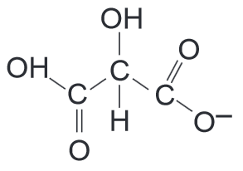

WACE 2016 Sample Exam Q28: Originally from WACE 3AB 2012
The active ingredient in aspirin tablets (acetylsalicylic acid) has the structure shown below:
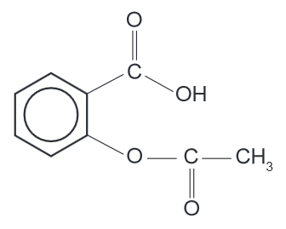
When acetylsalicylic acid is placed in water, some of it dissolves and ionises to form its conjugate base.
- Write the equation for the ionisation of acetylsalicylic acid in the space below, and identify the conjugate acid and base pairs in the reaction. Connect each acid-base pair with a line, and label the conjugate acid in the pair ‘A’, and the conjugate base ‘B’. (3 marks)

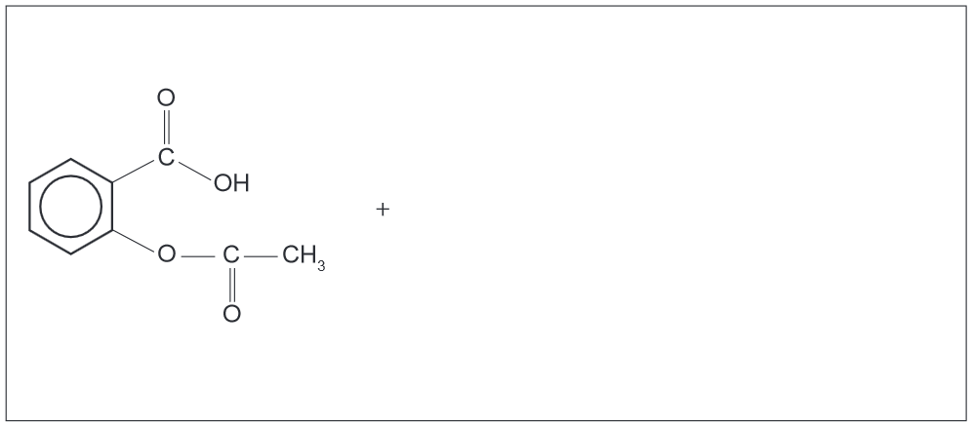
WACE 3AB 2010 Q28:
Like water, ammonia is able to react with itself, in the process known as ‘self-ionisation’. The equation for the self-ionisation of ammonia is below.
NH₃(aq) + NH₃(aq) ⇌ NH₄⁺(aq) + NH₂⁻(aq)
- Identify the conjugate acid and base pairs in the reaction. Join each pair with a line, and label the conjugate acid and base of each pair appropriately. (1 mark)

NH₃(aq) + NH₃(aq) ⇌ NH₄⁺(aq) + NH₂⁻(aq)

- At standard temperature and pressure, the equilibrium constant, K, for this reaction is about 1 x 10⁻³⁰. The self-ionisation of ammonia is an endothermic process. Will the value of K be less than or greater than 1 x 10⁻³⁰ at temperatures greater than 0 °C? Explain. (3 marks)

WACE 2AB 2014 Q20:
A few drops of water are added to one litre of pure nitric acid. Which one of the following best describes the resulting solution?
- A concentrated solution of a strong acid
- An acidic solution with a pH greater than 7
- A dilute solution of a weak acid
- A concentrated solution of a weak acid

WACE 2AB 2013 Q6:
Which one of the following lists the solutions, all 0.1 mol L⁻¹, in order of increasing electrical conductivity?
- HNO₃(aq) CH₃COOH(aq) H₂SO₄(aq)
- CH₃COOH(aq) NaCℓ(aq) MgCℓ₂(aq)
- H₂SO₄(aq) CH₃COOH(aq) HNO₃(aq)
- MgF₂(aq) KI(aq) HCℓ(aq)

WACE 2AB 2011 Q14:
Which one of the 0.02 mol L⁻¹ solutions below will have the highest pH?
- HCℓ
- H₂SO₄
- HNO₃
- CH₃COOH

WACE 2AB 2010 Q15:
In which list are the following 1.00 mol L⁻¹ solutions correctly arranged in order of decreasing pH:
calcium hydroxide, nitric acid, acetic (ethanoic) acid, sulfuric acid, ammonia and sodium chloride?
- Ca(OH)₂ > NH₃ > NaCℓ > CH₃COOH > HNO₃ > H₂SO₄
- NH₃ > Ca(OH)₂ > NaCℓ > HNO₃ > CH₃COOH > H₂SO₄
- HNO₃ > H₂SO₄ > CH₃COOH > NaCℓ > NH₃ > Ca(OH)₂
- H₂SO₄ > HNO₃ > CH₃COOH > NaCℓ > NH₃ > Ca(OH)₂
WACE 2016 Sample Exam Q7: Originally from WACE 3AB 2011
Which one of the following describes the acidity/basicity of a solution of the following compounds when dissolved in distilled water?
 | Ammonium  chloride | Potassium  carbonate | Sodium  nitrate | Sodium  ethanoate
(a) | acidic | basic | neutral | basic
(b) | acidic | basic | acidic | basic
(c) | basic | acidic | neutral | acidic
(d) | Basic | basic | basic | acidic

WACE 3AB 2015 Q19:
The following 1.00 mol L⁻¹ solutions are diluted by the addition of water. In which solution will the pH not change but the electrical conductivity will decrease?
- sodium carbonate
- ammonium chloride
- sodium chloride
- ethanoic (acetic) acid

WACE 3AB 2014 Q14:
Which of the following 0.1 mol L⁻¹ aqueous solutions has the highest pH?
- Ammonium hydrogensulfate
- Hydrochloric acid
- Potassium phosphate
- Sodium nitrate

WACE 3AB 2013 Q16:
A solution of hydrochloric acid conducts an electric current more readily than an equimolar solution of acetic acid. Which one of the following best explains this observation?
- Hydrochloric acid is a smaller molecule than acetic acid
- Hydrochloric acid is more soluble in water than acetic acid
- The equilibrium constant for the ionisation of hydrochloric acid is greater than that for acetic acid
- The pH of hydrochloric acid solution is always greater than that for acetic acid solution

WACE 3AB 2013 Q17:
Sodium hydrogensulfate was added to a swimming pool to reduce the pH of the water. Which one of the following equations best shows the reaction responsible for this?
- Na⁺(aq) + H₂O(ℓ) → NaOH(aq) + H⁺(aq)
- HSO₄⁻(aq) + H₂O(ℓ) → H₃O⁺(aq) + SO₄²⁻(aq)
- 2 HSO₄⁻(aq) + H₂O(ℓ) → H₃O⁺(aq) + H₂SO₄(aq) + SO₄²⁻(aq)
- HSO₄⁻(aq) + H₂O(ℓ) → OH⁻(aq) + H₂SO₄(aq)

WACE 3AB 2012 Q8:
Consider the following list of compounds:
- KNO₃
- Na₃PO₄
- Na₂S
- Ba(OH)₂
- Ca(NO₃)₂
Which one of the above compounds will dissolve in water to give a basic solution?
- (i), (ii), (iii), (iv)
- (ii), (iii), (iv), (v)
- (ii), (iii), (iv)
- (ii), (iii)

WACE 3AB 2012 Q12:
Some solid magnesium carbonate is added to dilute hydrochloric acid. Which one of the following equations best represents the reaction that occurs?
- MgCO₃ + 2 HCℓ → MgCℓ₂ + H₂O + CO₂
- MgCO₃ + 2 H⁺ → Mg²⁺ + H₂O + CO₂
- CO₃²⁻ + 2 HCℓ → 2 Cℓ⁻ + H₂O + CO₂
- CO₃²⁻ + 2 H⁺ → H₂O + CO₂

WACE 3AB 2011 Q16:
Which one of the following is the strongest electrolyte?
- NH₄Cℓ
- H₃PO₄
- H₂O
- CH₃COOH
TEE 2008 Q11:
Which one of the following classifications is correct?
 | KCℓ | KCH₃COO | NH₄Cℓ | KHSO₄
(a) | neutral | basic | acidic | acidic
(b) | neutral | basic | acidic | neutral
(c) | acidic | acidic | basic | basic
(d) | neutral | acidic | basic | acidic

TEE 2006 Q12:
Which one of the following correctly identifies the acidity of the listed salts when dissolved in water?
 | Potassium chloride | Sodium nitrate | Ammonium sulfate | Sodium carbonate
(a) | Neutral | Acidic | Acidic | Neutral
(b) | Acidic | Acidic | Basic | Acidic
(c) | Neutral | Neutral | Acidic | Basic
(d) | Acidic | Neutral | Neutral | Basic

TEE 2005 Q13:
Which one of the following correctly identifies the acidity, basicity or neutrality of each of the given solutions?
 | Sodium hydrogensulfate | Potassium phosphate | Ammonium chloride | Magnesium nitrate
(a) | Acidic | Acidic | Acidic | Basic
(b) | Neutral | Basic | Neutral | Acidic
(c) | Acidic | Basic | Acidic | Neutral
(d) | Basic | Neutral | Basic | Neutral

WACE 2AB 2014 Q38:
- Write an ionic equation for the reaction between phosphoric acid and barium hydroxide solution. Include state symbols. (3 marks)

- Phosphoric acid is a polyprotic acid. With the aid of equations, use phosphoric acid as an example to explain the term ‘polyprotic’ (4 marks)

- Phosphoric acid is a weak acid and a weak electrolyte. Barium hydroxide is a strong base and a strong electrolyte. Using equations containing phosphoric acid and barium hydroxide, explain the difference between the terms ‘strong’ and ‘weak’ when referring to electrolytes. (4 marks)

WACE 3AB 2011 Q29:
Write a relevant equation or equations to explain each of the observations shown in the table below.
(4 marks)
Observation | Explanatory equation/s
The pH of a NaHSO₄ solution is 5
A solution of Mg(OH)₂ is basic
A solution of Na₂HPO₄ is basic, while a solution of KH₂PO₄ is acidic

TEE 2006 Q5:
Sodium hydrogencarbonate is often used to increase the pH in swimming pools. Explain, with the aid of suitable equations, how adding sodium hydrogencarbonate affects the pH of the water. (3 marks)

WACE 2AB 2011 Q30:
The poisonous compound oxalic acid (H₂C₂O₄) is found in significant quantities in the leaves of the rhubarb plant, while its stalks contain only trace amounts, making them safe to eat. Oxalic acid is a polyprotic acid.
- Explain what is meant by the term ‘polyprotic’. (1 mark)

- Complete the table below by giving appropriate formulae. (2 marks)

Substance | Example
A polyprotic acid (other than oxalic acid)
A monoprotic acid

- Write the equations for the successive ionisation of oxalic acid. (2 marks)

- Explain why a 0.1 mol L⁻¹ solution of oxalic acid would have a higher pH than a 0.1 mol L⁻¹ solution of sulfuric acid. (2 marks)

HSC 1996 Q25:
Understanding of acids and bases has changed since Arrhenius first developed his theory. Although an acid-base reaction is known as neutralisation, the resulting salt solution is not always neutral. For example, a solution of the salt sodium sulfate is neutral, but a solution of sodium ethanoate (acetate) is basic.
- Write an equation to describe the formation of sodium sulfate from an acid-base reaction. Name the reactants. (2 marks)

- Explain why a solution of sodium ethanoate (CH₃COONa) is basic, which a sodium sulfate solution of the same concentration has a pH of 7.0. Write ionic equations to describe any reactions.
(4 marks)

TEE 2001 Q5:
- A 0.1 mol L⁻¹ solution of Na₂HPO₄ has a pH of about 10. Explain this, using an equation or equations. (3 marks)

- A 0.1 mol L⁻¹ solution of NH₄CH₃COO (ammonium acetate) has a pH of approximately 7. Explain this, using at least two equations. (3 marks)

WACE 3AB 2015 Q16:
An aqueous solution at 25.0 °C with a pH less than zero
- contains neither H⁺(aq) or OH⁻(aq) ions
- has a very high concentration of H⁺(aq) ions
- contains no OH⁻(aq) ions
- contains an equal concentration of H⁺(aq) and OH⁻(aq) ions

WACE 3AB 2014 Q16:
Consider the self-ionisation of water:
2 H₂O(ℓ) ⇌ H₃O⁺(aq) + OH⁻(aq) ΔH > 0.
Which of the following statements about aqueous solutions is true?
- All aqueous solutions contain H₃O⁺ and OH⁻ ions
- In any neutral aqueous solution at any temperature, [H₃O⁺] = [OH⁻]
- In aqueous solutions with pH greater than 7, [H₃O⁺] > [OH⁻]
- A neutral aqueous solution at 100 °C has a pH < 7

- I only
- I and II only
- I, II and III only
- I, II and IV only

TEE 2009 Q14:
Which one of the following statements best explains why water is classified as a weak electrolyte?
- A strong acid or strong base is required to ionise water molecules
- The rate of ionisation of water molecules is very slow
- When water ionises, the concentration of OH⁻(aq) is equal to the concentration of H⁺(aq)
- A small proportion of the water molecules will form H⁺(aq) and OH⁻(aq)

VCE 2015 Q22:
What is the pH of a 0.0500 mol L⁻¹ solution of barium hydroxide, Ba(OH)₂?
- 1.00
- 1.30
- 12.7
- 13.0
HSC 2014 Q14:
What is the pH of a 0.018 mol L⁻¹ solution of hydrochloric acid?
- 0.74
- 0.96
- 1.04
- 1.74

TEE 2009 Q17:
The pH of a solution formed by adding 200 mL of water to 20.0 mL of 2.00 mol L⁻¹ hydrochloric acid is:
- 0.39
- 0.70
- 0.74
- 1.39

TEE 2006 Q15:
20.0 mL of a 0.0100 mol L⁻¹ solution of NaOH is added to 20.0 mL of a 0.0300 mol L⁻¹ solution of HCℓ. What is the pH of the resulting solution?
- 1.52
- 1.70
- 2.00
- 12.00

VCE 2014 Q4:
If Solution X has a pH of 3 and Solution Y has a pH of 6, we can conclude that
- [H⁺] in Solution X is 1000 times that of [H⁺] in Solution Y
- [H⁺] in Solution X is half that of [H⁺] in Solution Y
- [OH⁻] in Solution Y is twice that of [OH⁻] in Solution X
- Solution Y must contain a stronger acid than Solution X
Use the following information to answer TEE 2008 Questions 25 and 26:
A student has 20.0 mL of 0.15 mol L⁻¹ Ba(OH)₂ solution and 30.0 mL of 0.223 mol L⁻¹ HCℓ solution.

TEE 2008 Q25:
What is the pH of the Ba(OH)₂ solution?
- 0.52
- 2.52
- 13.18
- 13.48

TEE 2008 Q26:
If the two solutions are mixed, what is the pH of the resulting solution?
- 1.13
- 1.86
- 2.43
- 3.16

TEE 2004 Q10:
What is the concentration of a Ba(OH)₂ solution that has a pH of 9.30?
- 1.00 x 10⁻⁵ mol L⁻¹
- 2.00 x 10⁻⁵ mol L⁻¹
- 2.50 x 10⁻¹⁰ mol L⁻¹
- 5.01 x 10⁻¹⁰ mol L⁻¹

TEE 2004 Q12:
20.0 mL of a 0.0100 mol L⁻¹ solution of NaOH is added to 20.0 mL of a 0.0300 mol L⁻¹ solution of NaCℓ. What is the pH of the resulting solution?
- 2.00
- 7.00
- 11.70
- 12.00

TEE 2002 Q26:
Which of the following statements best describes a neutral aqueous solution?
- The concentrations of H⁺ and OH⁻ are equal
- The pH is 7
- The solution contains no basic or acidic species
- The solution may contain dissolved salts

VCE 2015 Q22:
The following table shows the value of the ionisation constant of pure water at various temperatures and at a constant pressure.
Temperature (°C) | 0 | 25 | 50 | 75 | 100
K_{w} | 1.1 x 10₋₁₅ | 1.0 x 10⁻¹⁴ | 5.5 x 10⁻¹⁴ | 2.0 x 10⁻¹³ | 5.6 x 10⁻¹³

Given this data, which one of the following statements about pure water is correct?
- The [OH⁻] will decrease with increasing temperature
- The [H₃O⁺] will increase with increasing temperature
- Its pH will increase with increasing temperature
- Its pH will always be exactly 7 at any temperature

TEE 2001 Q30:
A chemistry measures the pH of four 1.0 x 10⁻² mol L⁻¹ acid solutions, and obtains the following results:
Experiment | Solution | pH
1 | 1.0 x 10⁻² mol L⁻¹ CH₃COOH | 3.4
2 | 1.0 x 10⁻² mol L⁻¹ H₃PO₄ | 2.2
3 | 1.0 x 10⁻² mol L⁻¹ HNO₃ | 2.0
4 | 1.0 x 10⁻² mol L⁻¹ H₂SO₄ | 1.4

Which experiment result must be incorrect?
- Experiment 1
- Experiment 2
- Experiment 3
- Experiment 4
WACE 3AB 2015 Q40:
Hydrogen fluoride, HF, is a highly dangerous and corrosive liquid that boils at near room temperature. It readily forms hydrofluoric acid in the presence of water and is an ingredient used to produce many important compounds, including medicines and polymers.
- The equilibrium constant (K) for the dissociation of hydrofluoric acid is 6.8 x 10⁻⁴, and for hydrochloric acid K is very large. To make a solution of hydrofluoric acid with the same pH as hydrochloric acid, a greater concentration of hydrofluoric acid is required. Explain why this is so. (3 marks)

- The salts, sodium chloride and sodium fluoride, readily dissolve in water. At 25.0 °C the pH of the sodium chloride solution is equal to 7 whereas the pH of the sodium fluoride solution is greater than 7. Explain this difference in pH. Include any relevant equation(s) to support your answer. (3 marks)

WACE 3AB 2015 Q29:
A 25.0 mL solution of nitric acid at 25.0 °C contains 8.50 x 10⁻³ moles of hydrogen ions.
- Calculate the hydrogen ion concentration and the pH of the solution. (2 marks)

- Calculate the pH of the solution after 20.0 mL of 0.300 mol L⁻¹ potassium hydroxide solution is added to the original 25.0 mL of nitric acid. (5 marks)

WACE 3AB 2013 Q41:
- Lead-acid storage batteries use Pb and PbO₂ electrodes. The overall equation is:
Pb(s) + PbO₂(s) + 4 H⁺(aq) + 2 SO₄²⁻(aq) → 2 PbSO₄(s) + 2 H₂O(ℓ)
  - Determine the number of moles of H⁺(aq) in a lead-acid battery that contains 4.50 L of 3.55 mol L⁻¹ sulfuric acid solution. Assume full ionisation. (1 mark)

  - Use the overall battery equation to determine the number of moles of H⁺(aq) consumed when discharged of this battery forms 138.1 g of PbSO₄(s).
The molar mass of PbSO₄ is 303.26 g mol⁻¹. (2 marks)

  - Use your answers to (i) and (ii) to determine the concentration of H⁺(aq) in the electrolyte in the discharged battery. Assume that the electrolyte volume remains constant, and ignore any changes due to the formation of water. (2 marks)

  - Use your answers to (i) and (iii) to show that when this battery discharges as described above, the change in pH of the electrolyte solution is negligible. Note that in any acid solution whose H⁺(aq) concentration is greater than 1 mol L⁻¹, the pH is negative. (3 marks)

WACE 3AB 2012 Q36:
Water is able to react with itself in the process known as ‘self-ionisation’ or ‘auto-ionisation’.
- Write the equation for the self-ionisation of water. (1 mark)

- At 25 °C, the value of K_{w} is approximately 1.0 x 10⁻¹⁴. At 10 °C, the value of K_{w} is approximately 2.9 x 10⁻¹⁵. (2 marks)

What are the relative concentrations of H⁺ and OH⁻ ions in a neutral water solution at 25 °C?
Circle the correct answer.

[H⁺] > [OH⁻] [H⁺] < [OH⁻] [H⁺] = [OH⁻]

What are the relative concentrations of H⁺ and OH⁻ ions in a neutral water solution at 10 °C?
Circle the correct answer.

[H⁺] > [OH⁻] [H⁺] < [OH⁻] [H⁺] = [OH⁻]

- Consider the values of K_{w} at 10 °C and 25 °C, and state whether the self-ionisation of water is an endothermic or exothermic process. Give a reason to support your answer. (3 marks)

WACE 3AB 2011 Q39:
A student was given three bottles, A, B and C. Each bottle was labelled with its contents as shown in the table below.
Bottle | Contents
A | 46.5 mL of 0.010 mol L⁻¹ HCℓ
B | 65.7 mL of 0.0555 mol L⁻¹ HNO₃
C | 20.9 mL of 0.4161 mol L⁻¹ NaOH

- Calculate the pH of the NaOH solution. (2 marks)

- The contents of all three bottles are placed in one beaker and mixed thoroughly. Calculate the pH of the final mixture. (10 marks)

TEE 2008 Q9:
A student was given a 0.100 mol L⁻¹ sulfuric acid solution and a 0.200 mol L⁻¹ hydrochloric acid solution. She tested the pH of the solutions using a pH meter and found that the pH of the sulfuric acid solution higher than that of the hydrochloric acid solution. Explain this observation. Include equations in your answer.
(4 marks)

TEE 2003 Q8:
The pH of a 0.0010 mol L⁻¹ solution of HCℓ is 3. The pH of a 1.0 mol L⁻¹ solution of CH₃COOH is also about 3. Explain these observations using equations where appropriate. (4 marks)

WACE 2016 Sample Exam Q6: Originally from WACE 3AB 2012
Consider the list below:
- PO₄³⁻
- 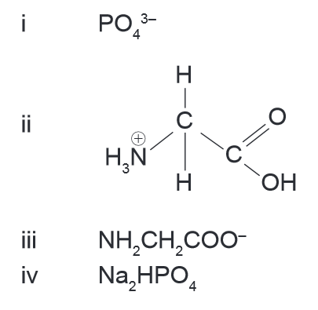
- NH₂CH₂COO⁻
- Na₂HPO₄
Which two of the above species, when mixed together in water, form a buffer solution?
- i and ii
- iii and iv
- i and iv
- ii and iii

WACE 2016 Sample Exam Q8: Originally from WACE 3AB 2010
Hydrochloric acid (HCℓ) is a stronger acid than the ammonium ion (NH₄⁺). Which one of the statements below is true?
- The equilibrium constant for the hydrolysis of HCℓ is smaller than that for NH₄⁺
- Cℓ⁻(aq) is a weaker base than NH₃(aq)
- Solutions of HCℓ will always have more hydrogen ions than solutions of NH₃
- The pH of a 0.1 mol L⁻¹ solution of HCℓ will be greater than the pH of a 0.1 mol L⁻¹ solution of NH₃

WACE 3AB 2014 Q13:
Which of the following is the strongest acid?
 | Acid | Acid dissociation (equilibrium) constant
(a) | CH₃COOH | 1.8 x 10⁻⁵
(b) | HCO₃⁻ | 5.6 x 10⁻¹¹
(c) | HF | 6.8 x 10⁻⁴
(d) | H₂C₂O₄ | 5.4 x 10⁻²

WACE 3AB 2013 Q18:
A buffer solution is prepared by mixing equal moles of sodium acetate (ethanoate) and acetic acid in water. Which of the following statements applies to the buffer?
- Addition of a few drops of concentrated nitric acid will produce more acetic acid molecules
- The sodium ions play a significant role in the buffering action
- Addition of water to the buffer will reduce its buffering capacity
- Most of the hydrogen ions will be supplied by water

WACE 3AB 2010 Q6:
Which one of the following pairs of substances forms a buffer in aqueous solution?
- HCℓ and NaCℓ
- H₂SO₄ and Na₂SO₄
- NH₄Cℓ and NaNH₂
- NaHCO₃ and Na₂CO₃

HSC 2014 Q8:
The graph shows the pH of a solution of a weak acid, HA, as a function of temperature.
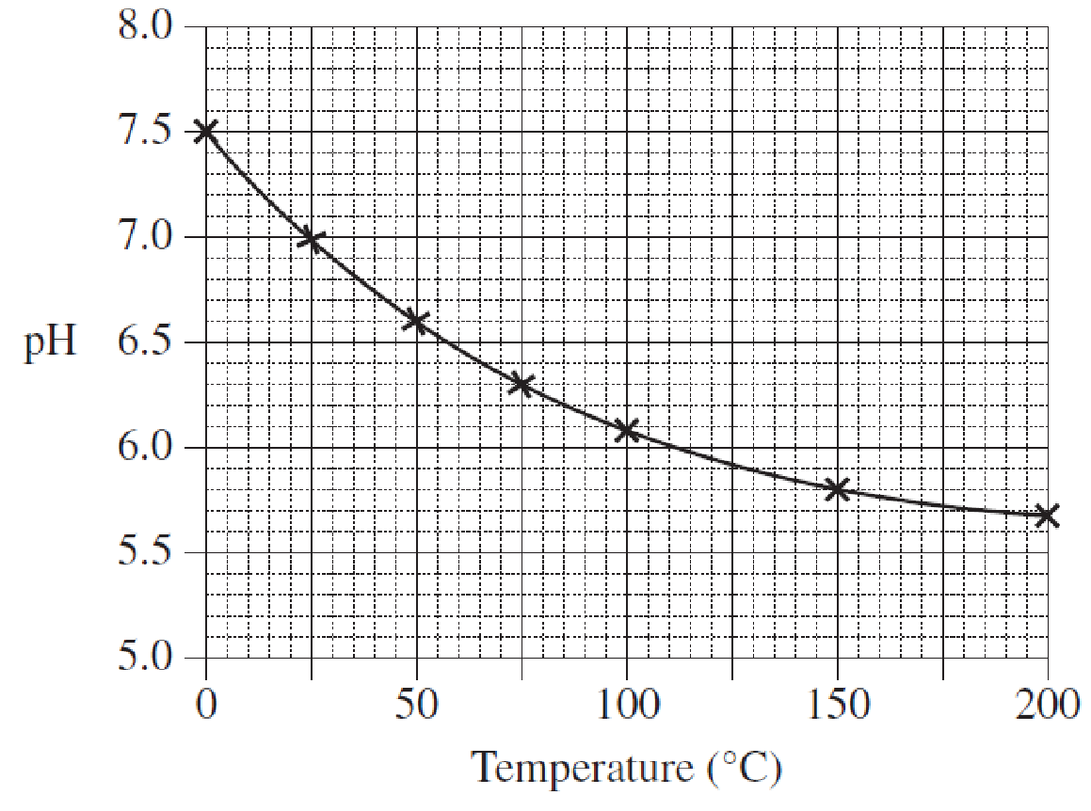
What happens as the temperature decreases?
- HA becomes less ionised and the H⁺ concentration increases
- HA becomes less ionised and the H⁺ concentration decreases
- HA becomes more ionised and the H⁺ concentration increases
- HA becomes more ionised and the H⁺ concentration decreases
WACE 3AB 2014 Q19:
A buffer solution is made by dissolving ammonium chloride in a dilute solution of ammonia. The following equilibrium exists in the prepared solution:
NH₃(aq) + H₂O(ℓ) ⇌ NH₄⁺(aq) + OH⁻(aq)
A small amount of a strong acid is added to the buffer solution. Once the equilibrium has been re-established, the effect would be:
- an overall decrease in the H⁺ ion concentration
- that the equilibrium has shifted to the left
- an overall increase in the NH₄⁺ ion concentration
- an overall increase in the OH⁻ ion concentration

WACE 3AB 2015 Q40:
Propanoic acid, CH₃CH₂COOH, is a weak monoprotic acid. When 0.500 mol of sodium propanoate (NaCH₃CH₂COO) is dissolved in 1.00 L of 0.500 mol L⁻¹ propanoic acid at 25.0 °C a buffer solution is formed.
- (i) Addition of 10.0 mL of 1.00 mol L⁻¹ HCℓ(aq) to this buffer does not significantly change its pH. Explain this observation, including any relevant equation(s). (3 marks)

(ii) State two conditions required to ensure that this system has a high buffering capacity. (3 marks)

One:

Two:

WACE 3AB 2013 Q31:
An aqueous solution is prepared that contains 0.1 mol L⁻¹ Na⁺ and 0.1 mol L⁻¹ HC₂O₄⁻.
- Write the two possible reactions for the hydrolysis of the HC₂O₄⁻ ion. (3 marks)

One:

Two:

- The pH of the solution was measured and found to be less than seven. Based on this observation, state which of the hydrolysis equations has the higher equilibrium constant. Use your understanding of equilibrium concepts to explain your choice fully. (4 marks)

WACE 3AB 2010 Q29:
Benzoic acid is found in many berries and some other fruits, and is used as a food preservative. The structure of benzoic acid is shown below. In an aqueous environment, benzoic acid ionises and exists in equilibrium with the benzoate ion.
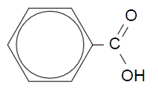
- Write the equation for the reaction between benzoic acid and water. (1 mark)



- Draw the structure (either benzoic acid or the benzoate ion) that would predominate in the acidic environment of the stomach. (1 mark)

- Show, using equations and the principles of equilibrium, how a solution of benzoic acid and the benzoate ion may behave as a buffer. (3 marks)

VCE 2012 Part 2 Q3:
The following weak acids are used in the food industry.
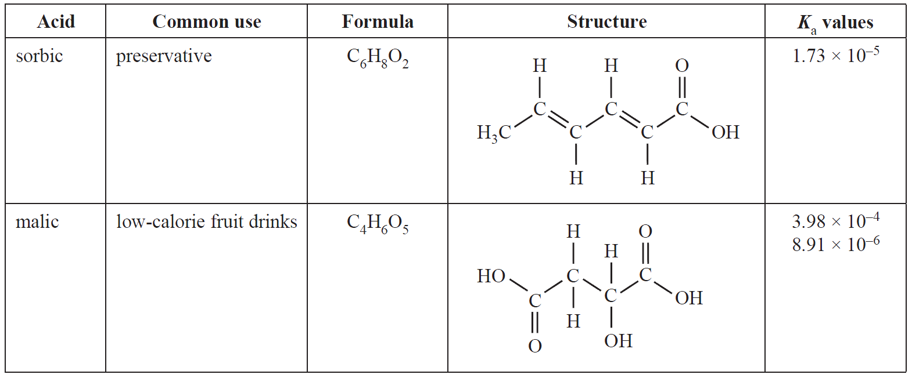
- What does the term ‘weak acid’ mean? (1 mark)

- (i) Why are two K_{a} values listed for malic acid? (1 mark)

(ii) The equation related to the first K_{a} value of malic acid is:

C₄H₆O₅(aq) + H₂O(ℓ) ⇌ C₄H₅O₅⁻(aq) + H₃O⁺(aq)

Write an appropriate chemical equation that relates to the second K_{a} of malic acid. (1 mark)

- Sorbic acid, CH₃(CH)₄COOH, has antimicrobial properties that are used to inhibit yeast and mould growth. However, its solubility yis very low. The more soluble potassium sorbate is used instead. The antimicrobial activity is retained because an equilibrium exists according to the equation

CH₃(CH)₄COO⁻(aq) + H₂O(ℓ) ⇌ CH₃(CH)₄COOH(aq) + OH⁻(aq)
sorbate ion sorbic acid

How would the addition of a small amount of 1.0 mol L⁻¹ hydrochloric acid affect the concentration of sorbic acid in solution? Justify your answer in terms of equilibrium principles. (2 marks)

HSC 2015 Q24:
- Explain why the salt, sodium acetate, forms a basic solution when dissolved in water. Include an equation in your answer. (2 marks)

- A solution is prepared by using equal volumes and concentrations of acetic acid and sodium acetate.

Explain how the pH of this solution would be affected by the addition of a small amount of sodium hydroxide solution. Include an equation in your answer. (3 marks)

WACE 3AB 2012 Q43:
Soaps function because their molecules dissolve in both grease and water. Water containing significant quantities of calcium and magnesium ions will not later properly with soap, and will form an insoluble ‘scum’ according to the reaction below. Water that does not later effectively is referred to as ‘hard’ water, and calcium ions are the primary cause of water hardness.
There are a number of methods that may be used to soften hard water. One of these involves the addition of Ca(OH)₂ to the water in the process known as liming.
In the liming process, the pH of water is raised when Ca(OH)₂(s) is added.
- Calculate the pH of 1.05 x 10³ L of water solution to which 125 mg of Ca(OH)₂ have been added. Assume all added Ca(OH)₂ dissolves. (3 marks)

The increase in pH (i.e., addition of OH⁻) of the water shifts the equilibria of the carbonate species in the water so that first HCO₃⁻ predominates, and as the pH is raised further, CO₃²⁻ predominates.
Hard water containing HCO₃⁻ has significant ‘buffering capacity’.
- Explain what is meant by the term ‘buffering capacity’. (1 mark)

- Write two equations that demonstrate the buffering capacity of hard water containing HCO₃⁻.
(2 marks)

- Write equations to show how the addition of OH⁻ shifts the equilibria of the carbonate species in the water. (2 marks)

HSC 2013 Q25:
An indicator is placed in water. The resulting solution contains the green ion, Ind–, and the red molecule, HInd.
Explain why this solution can be used as an indicator. In your response, include a suitable chemical equation that uses Ind– and Hind. (4 marks)

VCE 2014 Q5:
A 2% solution of glycolic acid, CH₂(OH)COOH, is used in some skincare products.
The equation for the ionisation of glycolic acid is:
CH₂(OH)COOH(aq) + H₂O(ℓ) ⇌ CH₂(OH)COO⁻(aq) + H₃O⁺(aq) K_{a} = 1.48 x 10⁻⁴
Sodium glycolate, CH₂(OH)COONa is a soluble salt of glycolic acid.

- How does the pH of glycolic acid change when some solid sodium glycolate is dissolved in the solution? Justify your answer. (2 marks)

HSC 1995 Q21:
The ionisation of any weak acid, HA, in water may be represented as
HA + H₂O ⇌ H₃O⁺ + A⁻
Acid dissociation constants for three weak acids are given below.
Acid | K_{a}
HX | 2.3 x 10⁻⁴
HY | 7.1 x 10⁻⁵
HZ | 5.2 x 10⁻⁴

- Arrange these three acids in order of decreasing acid strength. Explain your answer. (2 marks)

- If all three acids had the same concentration, which would best conduct electricity? Explain your answer. (2 marks)

WACE 2016 Sample Exam Q10:
Over the last 200 years, the pH of oceans has dropped from 8.2 to 8.1. A drop of 0.1 pH units represents an
- approximate 20% increase in the concentration of hydrogen ions
- increase of the hydrogen ion concentration by a factor of 10
- approximate 20% increase in pH
- insignificant change in hydrogen ion concentration, due to the large volume of the ocean

WACE 2AB 2010 Q13:
According to Arrhenius theory, what is produced when sodium hydroxide is dissolved in water?
- Hydroxide ions
- Electrons
- Water molecules
- Hydrogen ions

HSC 2014 Q3:
Which row of the table correctly matches the scientist(s) with their theory of acids?
 | Scientist(s) | Theory
(a) | Arrhenius | Acids contain oxygen
(b) | Brønsted and Lowry | Acids and proton donors
(c) | Davy | Acids are able to produce hydrogen ions in water
(d) | Lavoisier | Acids contain hydrogen

HSC 2010 Q8:
In a research report a student wrote, ‘Acids are compounds that contain hydrogen and can dissolve in water to release hydrogen ions into solution.’
Who originally stated this theory of acids?
- Arrhenius
- Brønsted-Lowry
- Davy
- Lavoisier

HSC 2006 Q11:
In 1884, Svante Arrhenius proposed a definition for acids. His definition was soon accepted as superior to that put forward by earlier chemists.
Why was Arrhenius’ definition seen as a major improvement?
- It explained why some acids do not contain oxygen
- It showed how the solvent can affect the strength of an acid
- It showed the relationship between pH and the concentration of H⁺ ions
- It could be used to explain why some acids are strong and others are weak

HSC 2004 Q5:
Which statement best represents Davy’s definition of an acid?
- Acids contain oxygen
- Acids are proton donors
- Acids contain replaceable hydrogens
- Acids ionize in solution to form hydrogen ions

WACE 2016 Sample Exam Q34:
Ocean acidification results from carbon dioxide dissolving in water and an equilibrium being established between the water and carbon dioxide to produce carbonic acid (H₂CO₃).
- Write a balanced equation for this equilibrium. (2 marks)

- The formation of carbonic acid leads to an increase in the hydronium ion (H₃O⁺) concentration in the water. Show the equilibrium that results in the formation of hydronium ions when carbonic acid reacts with water. (1 mark)

- State one problem that ocean acidification is causing for marine organisms. Explain how this problem arises and support your answer with an appropriate balanced equation. (3 marks)

HSC 2015 Q28:
The equipment shown is set up. After some time a ring of white powder is seen to form on the inside of the glass tube.
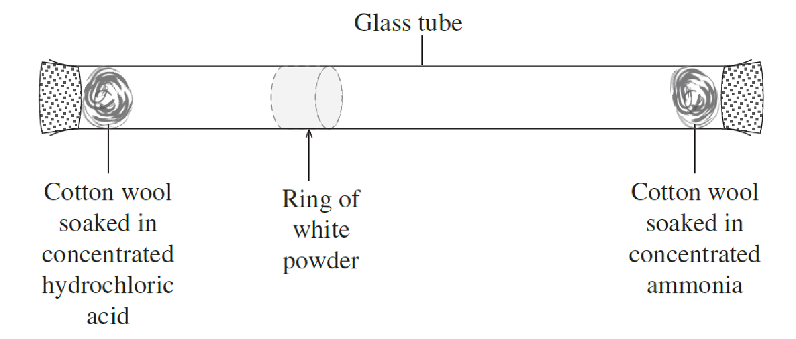
- Why would this NOT be an acid-base reaction according to Arrhenius? (1 mark)

- Explain why this would be considered a Brønsted-Lowry acid-base reaction. Include an equation in your answer. (2 marks)

